CURRICULUM VITAE

# PERSONAL INFORMATION:

Name: Xinhang Xu

Date of Birth: 06/11/1993

Address: 2900 Spafford St. Davis, CA, 95618, U.S.

Phone: (530)979-3691

Email: [xihxu@ucdavis.edu](mailto:xihxu@ucdavis.edu), [xinhangxu2024@gmail.com](mailto:xinhangxu2024@gmail.com)

# EDUCATION:

# Postdoc Researcher, University of California, Davis, California (03/2024 – present)

* [Fusion Plasma Diagnotics] Design and develop the far infrared tangential interferometer/polarimeter diagnostic(FIReTIP) and Terahertz high-k scattering system on the National Spherical Torus Experiment-Upgrade (NSTX-U), Princeton Plasma Physics Laboratory

**Ph.D. degree (2016 - 2023) , University of Science and Technology of China, Hefei, China**

* [Computational Plasma Modeling] Numerical study of the kinetic evolution of non-thermal electrons in Tokamak and its influence on cyclotron radiation
* [Fusion Plasma Diagnostics] Operate and upgrade millimeter-wave diagnostics (Electron Cyclotron Emission Imaging) on the Experimental Advanced Superconducting Tokamak (EAST), Hefei city, Anhui, China

Bachelor’s degree (2012 – 2016), **Anhui University of Science and Technology (AUST), Huainan, China**

* [Computational] Dynamics of a Particle Moving Along a Curvilinear Path

**Research activities:**

* + Fusion plasma diagnostics [Laser-aided diagnostics, millimeter-wave, terahertz]

I specialize in the design and development of various **non-invasive fusion plasma diagnostics,** including **laser-aided scattering, laser/millimeter-wave-based interferometry,** and **terahertz/millimeter-wave spectroscopy.** I have **two years of experience in scattering diagnostics design and development**, where I led the implementation of the NSTX-U High-k Scattering System at PPPL for measuring electron density and fluctuations. I also have **two years of experience in interferometer development**, contributing to the design and implementation of the **NSTX-U Far-Infrared Tangential Interferometry and Polarimetry (FIReTIP) System** at PPPL for density measurement and feedback control. Additionally, I have **nine years of experience in millimeter-wave/terahertz spectroscopy diagnostics**, including the design and deployment of **Electron Cyclotron Emission Imaging (ECEI) systems** on the EAST and DIII-D tokamaks.

Throughout these projects, I developed a deep understanding of **diagnostic principles, performance evaluation of key components,** and **custom device development**. For scattering, interferometer, and spectroscopy systems, I am proficient in **optical ray-tracing simulation (Code V), experimental measurement, custom circuit design and debugging (KiCad), automation and control programming (LabVIEW),** and **3D modeling (CATIA)**, as well as **experimental installation, commissioning, and application**.

I have **seven years of tokamak experimental experience (EAST)** and have completed fusion experiment safety training, equipping me with strong hands-on experimental skills. Since 2016, I have been actively involved in **fusion device physics campaigns**, excelling in collaboration and communication with physicists and engineers, particularly in **leading and supporting experimental campaigns**.

As a **plasma research scientist**, I led the development of **experimental data interpretation programs** (in MATLAB and Python) for **fast data analysis, physics studies, diagnostic system calibration, and theoretical model validation.** In addition, I have studied and worked on **thermal management of equipment**, including performing heat dissipation simulation and analysis using **COMSOL Multiphysics**.

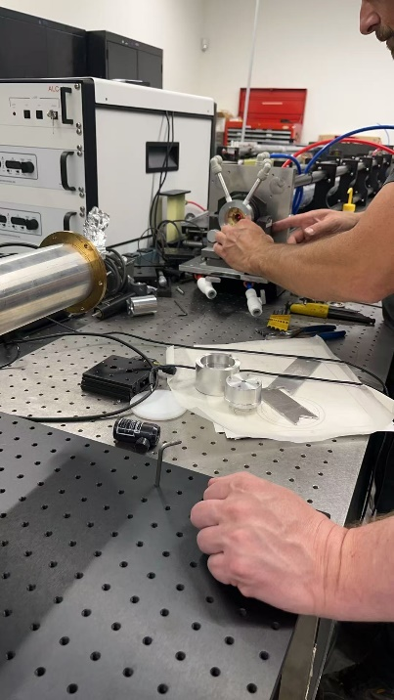 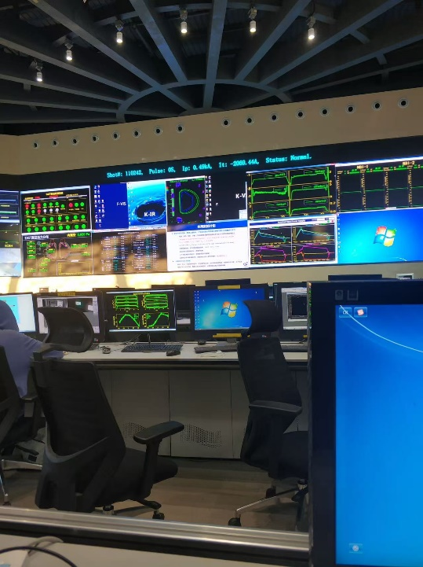 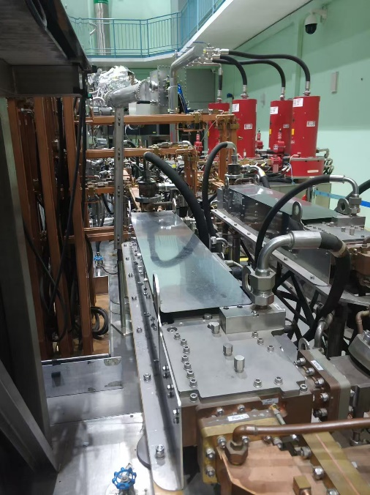 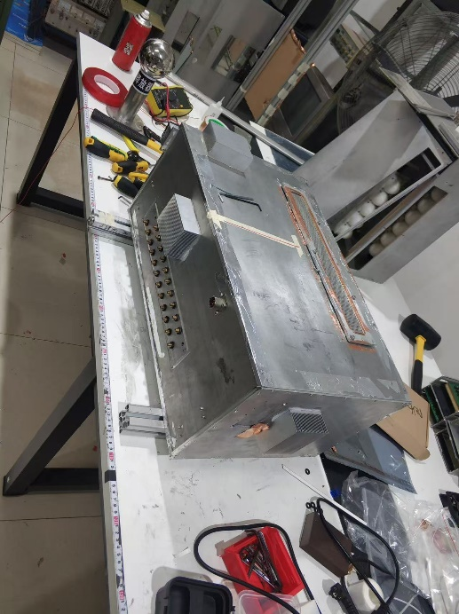

Software: Code V, Catia, KiCad. HFSS, COMSOL Multiphysics, LabVIEW

* + Computational plasma modeling [kinetic dynamics modeling, synthetic diagnostics modeling]

I developed a efficient kinetic program that combines the spectral method of the CODE program with the object-oriented programming approach of the NORSE program, enabling the computation of the evolution of the electron distribution function in 0D2P phase space (i.e., zero spatial dimensions and two momentum dimensions). This method can fully describe the evolution of the electron velocity distribution during a discharge, encompassing key physical processes such as electric field driving, test-particle collisions, synchrotron radiation damping, and the currently most complete runaway electron avalanche source term. As a result, it allows self-consistent investigation of the dynamical evolution of the kinetic equation under time-varying background parameters (e.g., plasma density, loop voltage).

Compared with previous kinetic solvers that primarily target steady-state backgrounds, the algorithm proposed in this work significantly improves computational efficiency while maintaining high accuracy, making it especially suitable for studying the evolution of non-thermal electron distribution functions in changing backgrounds. By introducing object-oriented programming concepts, the program structure becomes clearer and more extensible, facilitating the coupling of additional physical processes or adaptation to more complex discharge scenarios.

# RESEARCH EXPERIENCE:

# Postdoc Research with Professor Neville C Luhmann and Professor Yilun Zhu([amzhu@ucdavis.edu](mailto:amzhu@ucdavis.edu))

March 2024 -- September 2025 **University of California, Davis**

* + Develop the program for lasers of high-k scattering system and FIReTIP system based on LabVIEW software, including the auto-laser cavity adjustment, auto-beam profile measurement and laser data analysis.
  + Design the Wilkinson power divide for BEST system.
  + Investigate the influence of the Cotton–Mouton effect on interferometer diagnostics using 1D FDTD simulations and the NSTX magnetic profile.

**Ph.D. Student Research Assistant with Professor. Jinlin Xie** ([jlxie@ustc.edu.cn](mailto:jlxie@ustc.edu.cn)), October 2017 -- November 2023 **University of Science and Technology of China**

* + Design the frequency selective surface for millimeter-wave imaging diagnostics on EAST tokamak, Quasi-optical anti-reflection surface.
  + Build 2D beam tracing simulation program based on Finite Difference Time Domain code.
  + Develop the millimeter-wave (transmitter/receiver/local oscillator) optics system for Electron Cyclotron Emission Imaging and Microwave Imaging Reflectometer on EAST tokamak.
  + Mechanical design for EAST millimeter-wave imaging diagnostics’ optics housing and shielding crates
  + Analysis the runaway electron and its emission in tokamak with kinetic equation.
  + Operate millimeter-wave imaging diagnostics on EAST tokamak

**Master Student Research Assistant with Professor. Wandong Liu** ([wdliu@ustc.edu.cn](mailto:jlxie@ustc.edu.cn)), October 2016 -- September 2017 **University of Science and Technology of China**

* + Operate millimeter-wave imaging diagnostics on EAST tokamak.
  + Data interpretation for EAST Electron Cyclotron Emission Imaging experimental result.

# PUBLICATIONS:

1. *XU Xinhang, et al. "Improvement of transmittance using groove structured surface for microwave imaging diagnostics in tokamak plasmas." 2020 45th International Conference on Infrared, Millimeter, and Terahertz Waves (IRMMW-THz). IEEE, 2020.*

*[impact]* *Reducing reflections from the lens surface and improving data quality.*

*[contribution] Paper writing, theorical analysis and experiment research.*

1. *Xu, Xinhang, et al. "Analysis of the Anomalous Doppler Effect from Quantum Theory to Classical Dynamics Simulations." Chinese Physics B (2025).*

*[impact]* *Explaining the fundamental physics of wave-particle interaction from angular conservation.*

*[contribution] Paper writing, theorical analysis and experiment research.*

1. *Gao, BingXi, et al. "Diagnostic capacity of electron cyclotron emission imaging system with continuous large observation area on EAST tokamak." Review of Scientific Instruments 89.9 (2018).*

*[impact]* *Providing direct measurements of the 2-Delectron temperature dynamics in a continuous large observation area with high temporal and spatial resolution.*

*[contribution] Experimental data analysis.*

1. *Liu, Xianzi, et al. "High-wavenumber Collective Scattering Diagnostic System for EAST and NSTX-U Tokamaks and Synthetic Diagnostic System Development." APS Division of Plasma Physics Meeting Abstracts. Vol. 2024. 2024*

*[impact]* *Aiming to study high-k electron density fluctuations and providing a measurement of the -spectrum of the electron temperature gradient (ETG).*

*[contribution] Methodology discussion.*

1. *Han, Dongqi, et al. "In situ relative self-dependent calibration of electron cyclotron emission imaging via shape* *matching." Review of Scientific Instruments 89.10 (2018).*

*[impact]* *Providing a direct and effective way to calibration the microwave diagnostic channels*

*[contribution] Methodology discussion*

1. *Fei-xue, G. A. O., et al. "Evaluation of optical performance of microwave reflection imaging system on EAST tokamak." Nuclear Fusion and Plasma Physics 42.2 (2022): 187.*

*[impact]Testing and benchmark the optical system of microwave diagnostic*

*[contribution] Experiment and Methodology discussion.*

1. *Zihan, L. I., et al. "A synthetic diagnostics platform for microwave imaging diagnostics in tokamaks." Plasma Science and Technology 26.3 (2024): 034006.*

*[impact]* *Interpreting experimental diagnostics data in tokamaks*

*[contribution] Methodology discussion*

## Presentations:

* + Oral presentation: The 8th Graduate Academic Forum on Plasma Physics and Fusion Engineering, USTC, China (May 2023)
  + Poster: The 45th International Conference on Infrared, Millimeter, and Terahertz Waves

(Nov 2020)

* + Oral presentation: 2023 Plasma Mixture Simulation Workshop, HeFei, China.

(Oct 2023)

## Student mentoring experience:

1. **Ziwei Qiang** (2019 - 2023), University of Science and Technology of China , “Sawtooth recognition by Electron Cyclotron Emission Imaging on EAST ”. (Ph.D.)
2. **Yunjiao Zhang** (2019 - 2023), University of Science and Technology of China , “Automatically bad channel recognition and substitution of ECEI by SVM(Support Vector Machine)”. (Ph.D.)
3. **Yixiong Jiang** (2020 - 2023), University of Science and Technology of China , “Principal Component Analysis on Electron Cyclotron Emission Imaging”. (Master)
4. **Zihan Li** (2018 - 2023), University of Science and Technology of China , “Electron cyclotron emission intensity calculation and propagation in plasma ”. (Ph.D.)
5. **Dan Shao (**2022 - 2023), University of Science and Technology of China , “Active 2D millimeter- wave imaging reflectometer optics design and development”. (Ph.D.)
6. **Wenxiang Li** (2022 - 2023), University of Science and Technology of China , “ Runaway electron dynamic study and numerical simulation in fusion plasma”. (Ph.D.)
7. **Jinchen Yang** (2022 - 2023), University of Science and Technology of China , “ Ultrawide bandwidth F-band antenna design, development, laboratory testing.”. (Ph.D.)
8. **Lifu Zhang** (2018 - 2023), University of Science and Technology of China , “ Dual-band millimeter- wave optics combination and quasi-optics diplexer surface development ”. (Ph.D.)
9. **Feixue Gao** (2018 - 2023), University of Science and Technology of China , “ EAST Microwave Imaging Reflectometer experimental data intperetation”. (Master)

**Certification of highest degree**



